Theory Of Automata
Date: September 23th 2025
Course Instructor(s)
Ms. Shaharbano, Ms. Bakhtawar, Ms. Abeeha, Mr. Kashan, Mr. Kashif, Mr. Ubaid Ullah

Sessional-I Exam
Total Time (Hrs): 1
Total Marks: 40
Total Questions: 3

Roll No Section Student Signature

Do not write below this line
INSTRUCTION:

Return the question paper.
- Read each question completely before answering it. There are 3 questions on 1 page 2 sides.
- In case of any ambiguity, you may make assumptions. But your assumption should not contradict any statement in the question paper.
- Start each question in a new page.
CLO #2: Prove properties of languages, grammars and automata with rigorously formal mathematical methods.

Question 1: 5 mins (5) Points
- Draw the transition table for the given Epsilon-NFA.
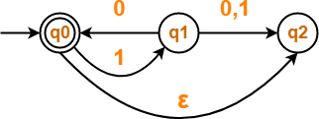

 | 0 | 1 | E
q0 | {} | {q1} | {q0,q2}
q1 | {q0,q2} | {q2} | {q1}
q2 | {} | {} | {q2ad}

- Let L= {ab, aa, baa}. Which of the following strings are in L*: abaab, aaabaa, aaaabaaaa, baaaaabaaaab, baaaaabaa,
- Is (a* + b*)* equivalent to (a + b)* ? Why or why not?
Answer: Yes, they are equivalent. The strings generated by both will be the same. (a+b)* will always have all combinations of a and b. (a*+b*)* cannot generate anything unique that is not already present in (a+b)*
- Is L(Φ) = {𝝀 } ? Justify your answer.
Answer: No, it is not. LHS represents an empty language, a language with nothing in it (aka empty set). Meanwhile RHS is a set with lambda in it (aka, not empty set)
- Give one use case of using epsilon NFA.
ENFAs give us the convenience that DFA’s and NFA’s don’t. It allows us to move to a different state without needing to consume an input.
CLO #3: Design of automata, RE.
Question 2(a): Design DFA for the given languages and also write the RE for part (I) and part (III).

20 mins (5*4) Points
- L = {ab^{n}w : n >= 3, w ∈ {a,b}⁺}
  - E.g. abbba, abbbb, abbbbba, are valid. a, ab, abb, b, ba, are invalid.
RE: abbbb*(a+b)(a+b)*
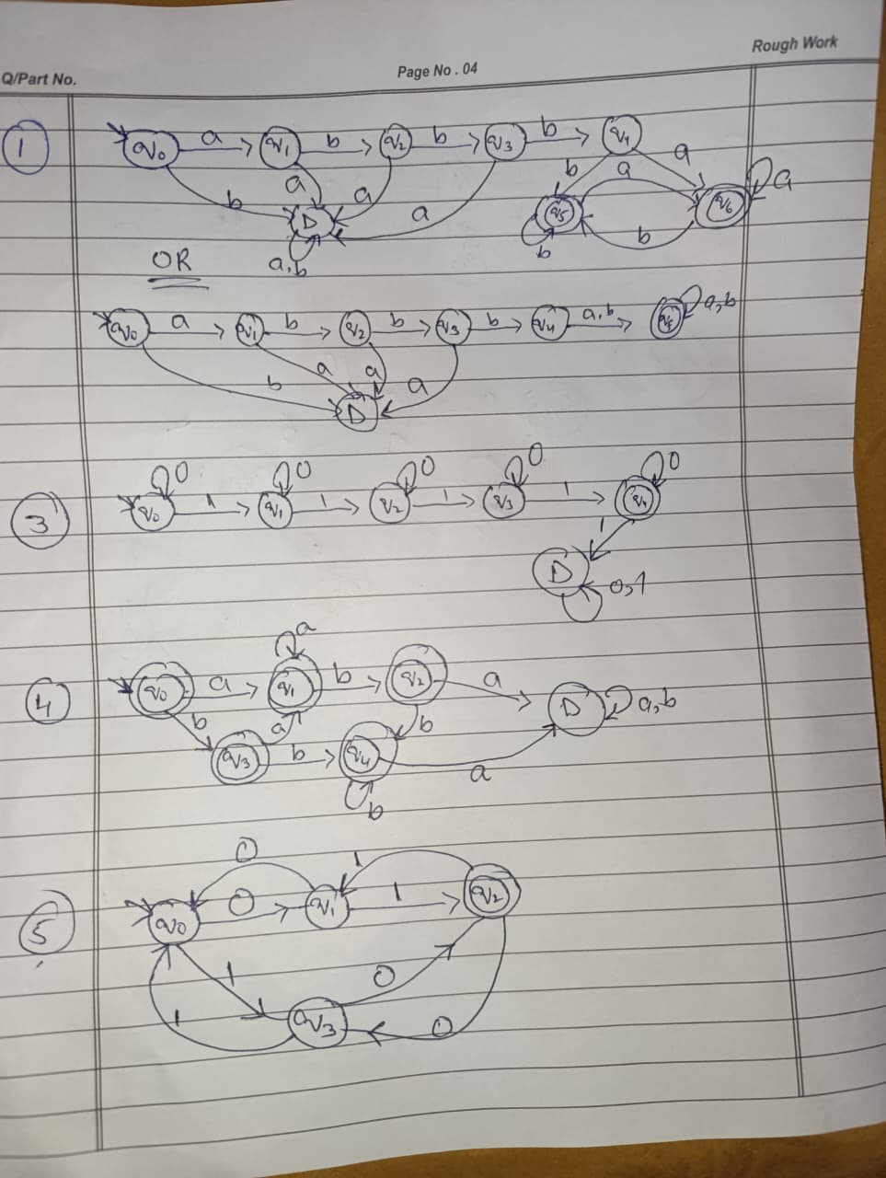

- L = {w | na(w) >= 3, nb(w) = 2, w ∈ {a,b}*}
  - E.g. ababa, aabaab, abbaaa, are valid. a, ab, aabb, bb, baaaaa, are invalid.

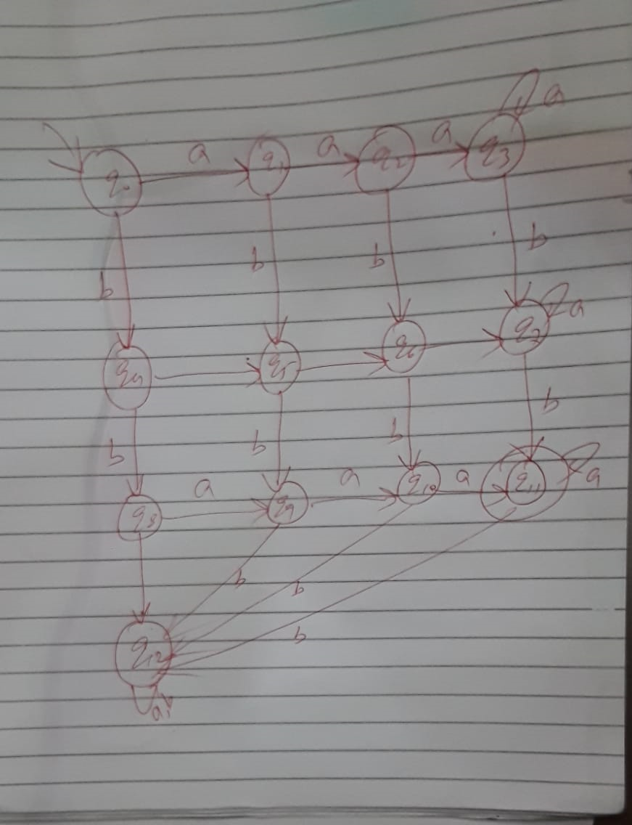

- Design a DFA that accepts a set of strings containing exactly four 1's in every string over the alphabet
{0,1}. E.g. 101000011, 1110001
RE: 0*10*10*10*10*
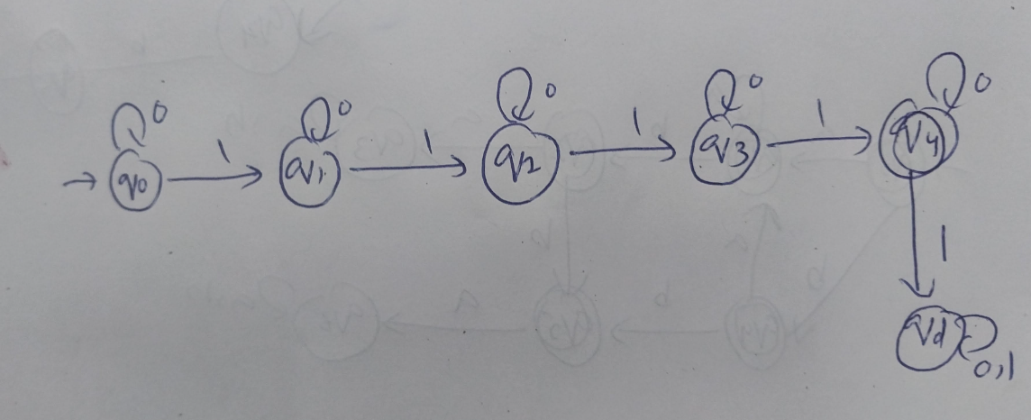
- Design a DFA over the alphabet {a,b} which accepts strings that do not contain the substring ‘aba’ or ‘bba’.
Solution
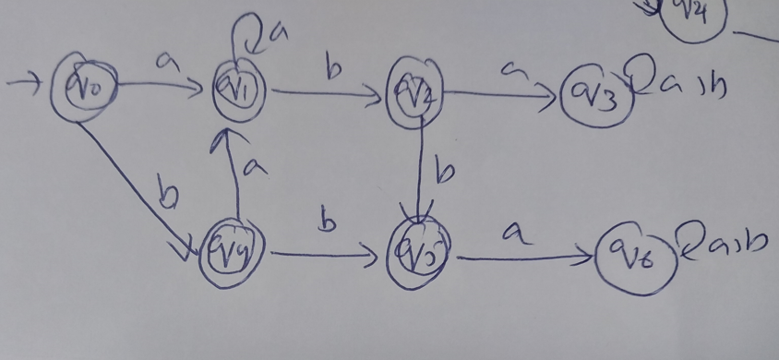
- Design a DFA over alphabet {0,1} which accepts an odd no of 0’s and an odd no of 1’s.
Solution
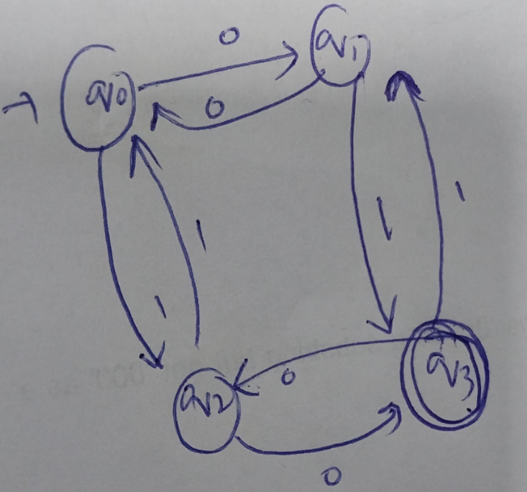
CLO #3: Design of automata, RE.

Question 2(b): 20 mins (3+3+4) Points

- Let’s say you’re writing a RegEx for a script that reads a paragraph and finds all words that start with an ‘a’ or ‘A’ and end with ‘e’. Do keep in mind that if the word contains any numeric value, or special characters then it will not be accepted.

Accepted words: Apple, apple, Acre, acre, Acne, acne, etc.
^[Aa][a-zA-Z]*e$
(acceptable without the ^ and $ symbols as well)
- Suppose you’re making an application where people can write a 6 digit hexadecimal color code, and it shows them the matching color. To ensure that people write the correct color codes, you have to ensure that the codes are written in hexadecimal. Write the RegEx that can be used for this purpose. Also, ensure that the written code is case-insensitive.
Valid Inputs:#AB012C, #000000, #123DEF, #FFFFFF Invalid Inputs:#GH1234, F#12345, 1234ABC, 1, A, #, #12
^#([0-9a-fA-F]{6})$
(acceptable without the ^ and $ symbols as well)
- Your application accepts time in 24-Hour format only. To ensure all the details are entered correctly, you are required to write a RegEx that checks whether the user input is in 24-Hour format or not.

Correct Input: 09:45, 23:59, 00:00, 13:01
Incorrect Input: 24:00, 9:5, 71:71, 21:76
^(2[0-3]|[01]\d):[0-5]\d$
(acceptable without the ^ and $ symbols as well. \d and [0-9] are interchangeable )
CLO #4: Transform between equivalent NFAs, DFAs.
Question 3: (Conversion of NFA to DFA) 15 mins (5) Points Convert the following NFA into its equivalent DFA. where 𝚺 = {0,1}
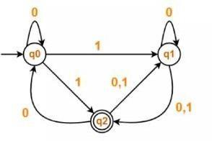
Solution
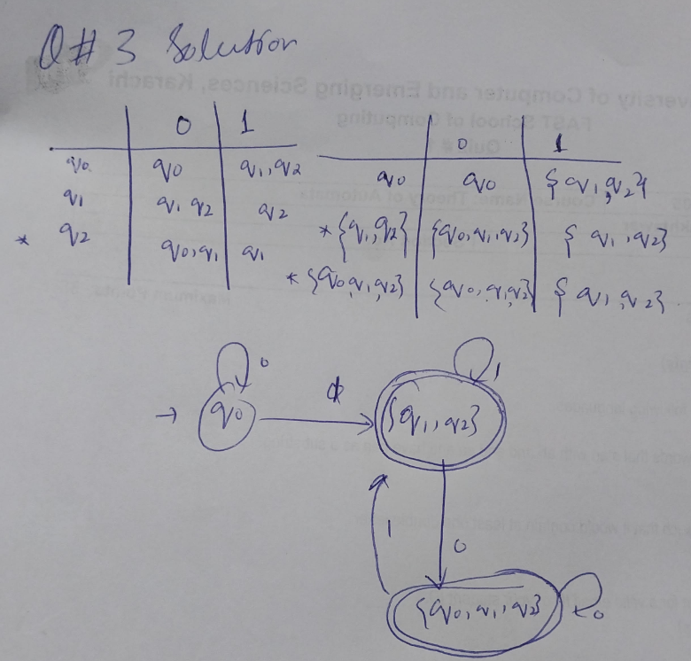

=========================== Best of Luck ===========================

